**Wireframe**

Project Title:

NBA Data Analysis project

The dashboard (Overview) of the project looks like this, have information about various features from the dataset.

**By, Sourav Mandal**

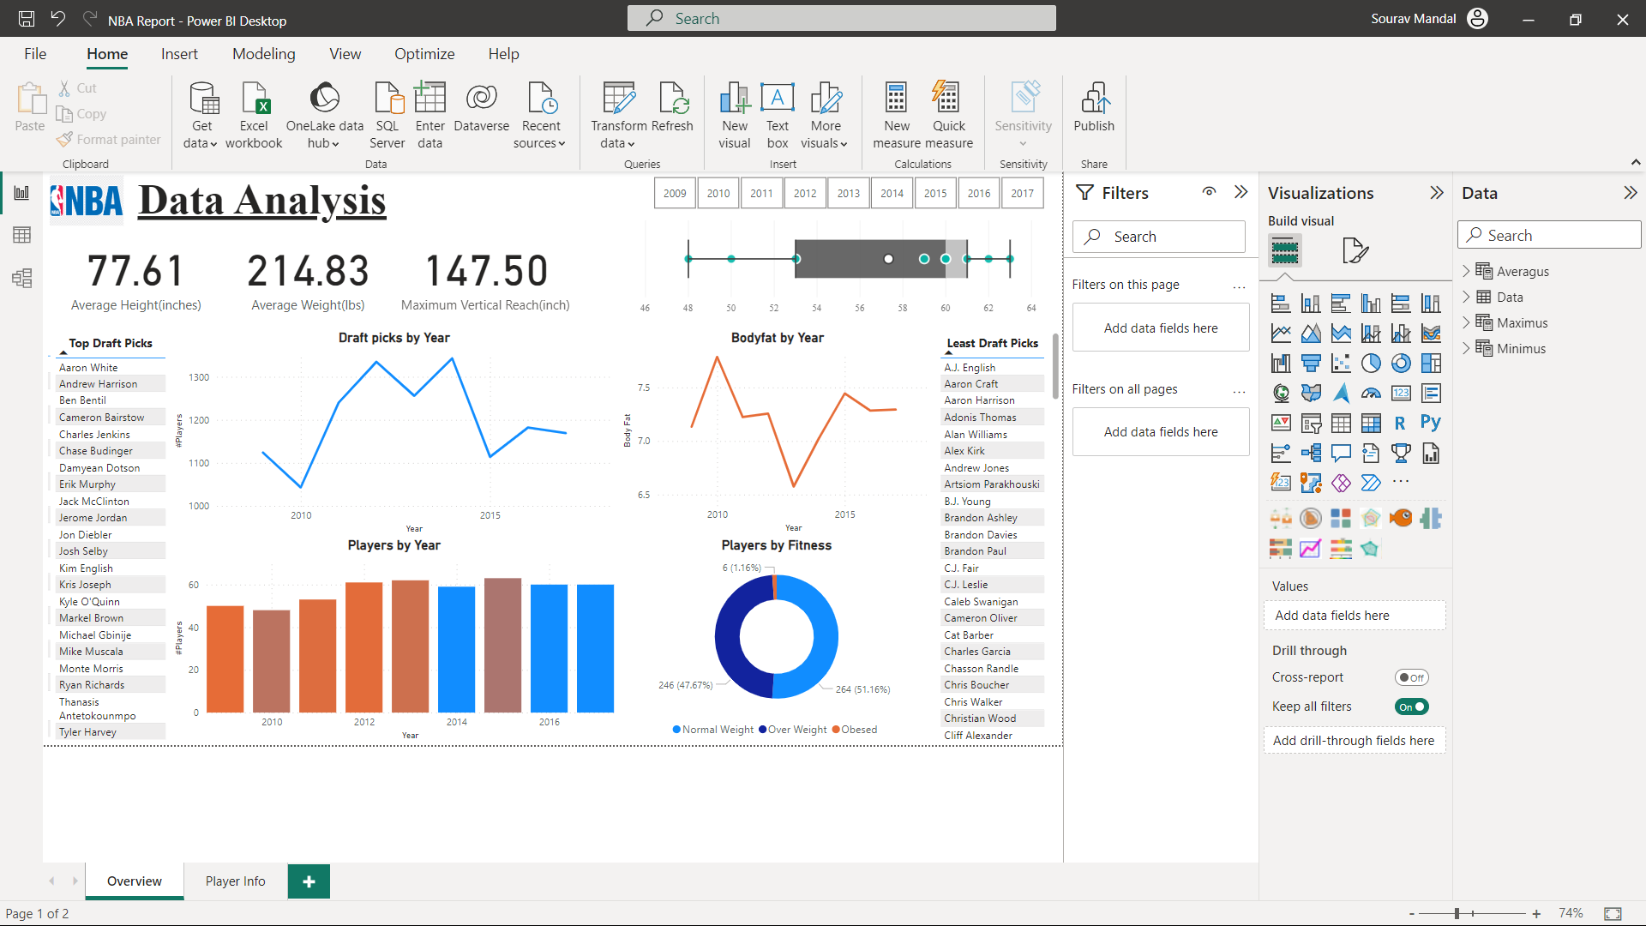

The Player info page looks like this, which is also a drill through page.

Now Let us select any player from the top draft picks and drill through it for more info.

Now, the Player info page will appear with the following details, here the background of the Height weight tab, gives about the fitness of the Player (Underweight, Normal weight, Overweight or Obese)

Also, an AI Q&A card is added for more insights, where you can put your own questions for analysis or can select from show all suggestions.

Select any of the given questions and get the insight.

For example, select maximum of minimum ability and get the insight.

Next, CTRL + click on the backward arrow to return to the overview page.

Next, we can filter the charts by the year slicer, so select any of the given year from the above slicer, for example, 2013 and see the personalised dashboard.

Now to reset the dashboard click on the selected year to unselect it.

Also, we can filter the dashboard, by the charts as well, for example select the normal weight from the donut chart.

Now the dashboard is filtered as per players with normal weight.

Also, we can select the overweight section to filter the dashboard for the overweight players.

We can then unselect the section to reset the dashboard.

We can also hover over the charts for more details by the tooltip.

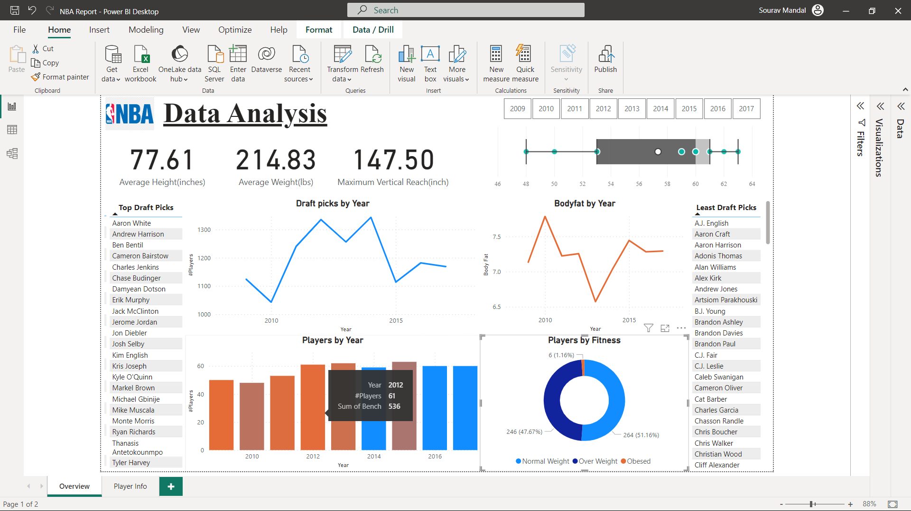

For example, in the bar chart, information for total no. of players and benched players are shown.

For example, by hovering over the boxplot, we can get info about the distribution of the players.

Finally, unselect all to see the actual dashboard.

